Patellar Tendon Rehabilitation Guidelines

- Take 6 weeks off from any sport activity that increases your pain to 5/10 or higher, where 0 is no pain and 10 is the worst pain imaginable
- If you are able to participate in sport activity with no more than 2/10 pain prior to the 6 week time-point, you can gradually resume full sport activity sooner
- Please perform the following exercises daily for the next 6 weeks
- If the stretching irritates your symptoms then skip those exercises until they don’t reproduce any symptoms
- Start with the isometric exercise. When you are able to do the leg extensions with less than 5/10 pain, progress to the leg extensions. Similarly, when you are able to do the squats with less than 5/10 pain, progress to the squats.
- Squat Progression
  - Perform the first set at the highest weight you did yesterday
  - If the first set is pain-free, increase resistance (weight in backpack) by 10 pounds
  - If you have pain >5/10 with the exercises or the next morning, decrease weight

Guidelines for Pain

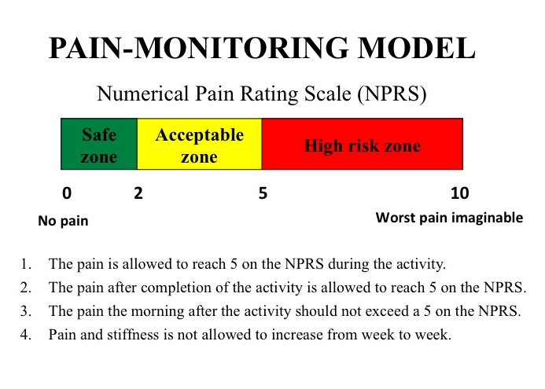

Exercises

Isometric Quadriceps Strengthening: Position yourself in sitting with your knee bent about halfway. Place a strap around your shin or set up a leg extension machine bar to push against. Tighten up your quadriceps muscle by pushing into the strap or bar with 50-70% of your maximum effort. Hold for 45 seconds. Repeat 4 repetitions, 3 times a day.

*Technique tip: if you use a leg extension machine, remember the goal is to not move the weight.

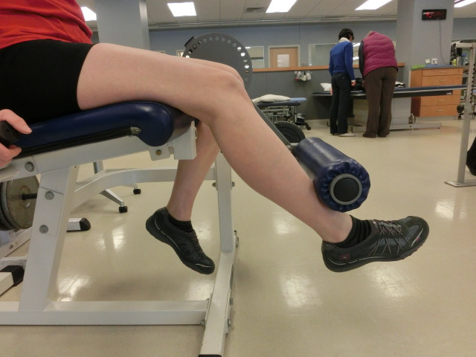

Knee Extensions: Using a leg extension machine, kick your leg slowly through about half of your range of motion (45-90 degrees). Gradually increase the range of motion as your pain allows, following the pain monitoring model. Repeat 10-15 repetitions, 3 sets, once a day.

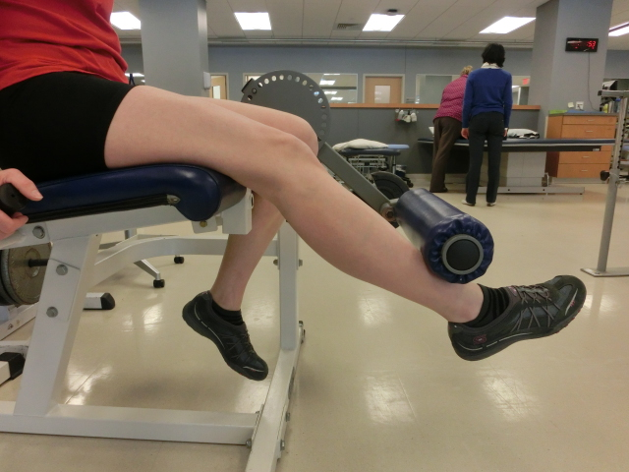

Decline Board Squats: Do a squat on a 25 degree decline board. On the way down, use only your injured leg. On the way up, use both legs. Do 3 sets of 15 repetitions, once a day. Repeat on the other side.

* Technique tip: Make sure your knee stays in line with your second toe, avoiding the knee traveling inwards across your body.

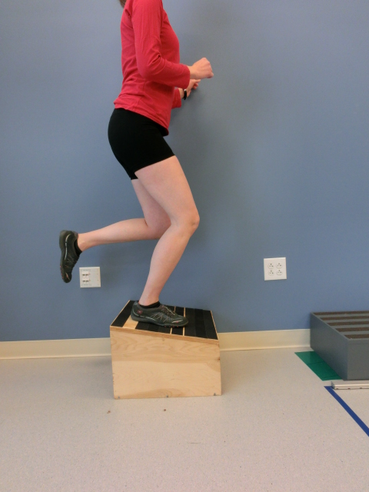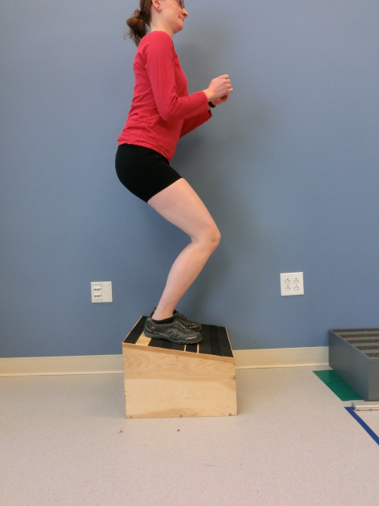

Hamstring Stretch: Sit up straight with one leg extended in front of you. Lean forward slightly until you feel a stretch in the back of the thigh. Hold for 30 seconds. Repeat on the other side.

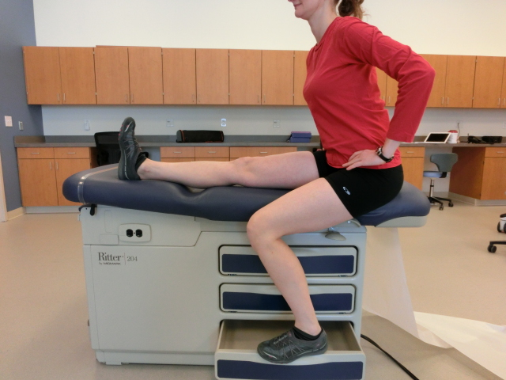

Quadriceps Stretch: Stand with something to hold onto for balance. Bend your knee, pulling your heel toward your buttock until you feel a stretch in the front of your thigh. Hold for 30 seconds. If this irritates your knee at all, you can modify the stretch by placing your foot on a chair and then moving your hips forward.

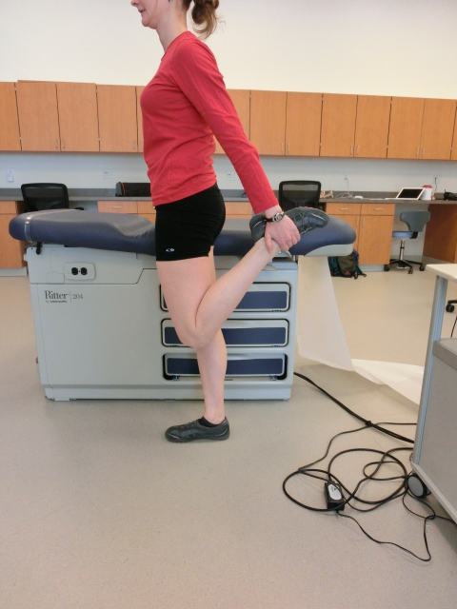

If you have any questions, problems, or are unsure of how to progress, please contact the study team!

Karin Silbernagel, PT, ATC, PhD Jen Zellers, PT, DPT
kgs@udel.edu jzellers@udel.edu
302-831-4808 302-831-7422

